**Install couchDB on Linux EC2 instance**

First, enable the EPEL Repo on your instance by editing the file /etc/yum.repos.d/epel.repo and setting it to enabled.

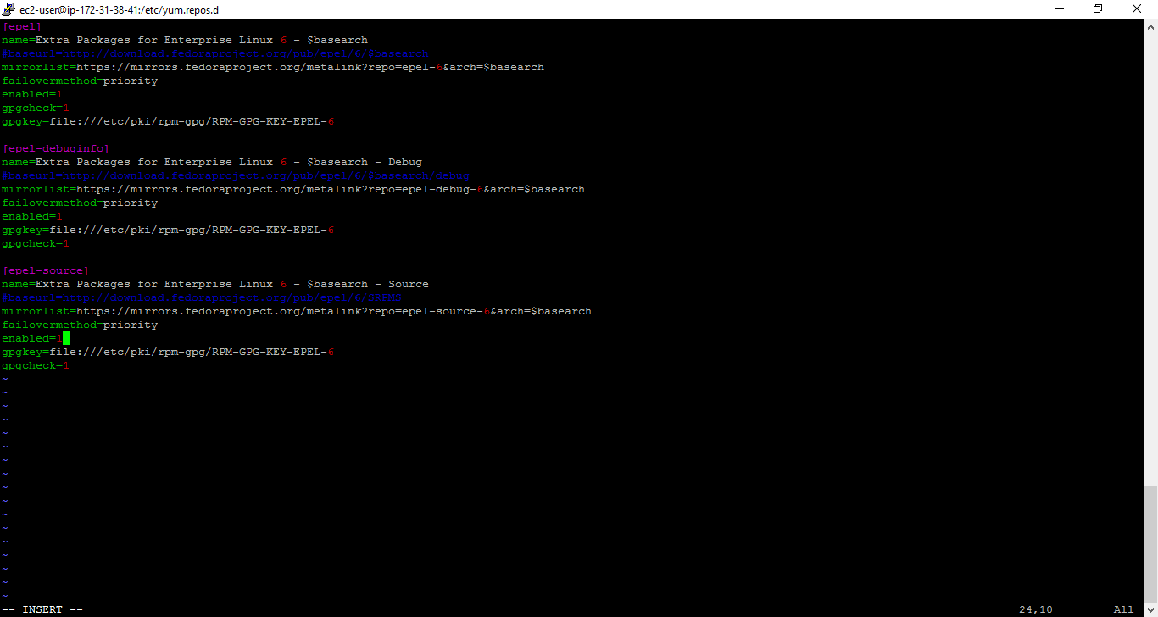

**Core deps and dev tools**

sudo yum install gcc gcc-c++ libtool libicu-devel openssl-devel autoconf-archive erlang python27 python-sphinx help2man

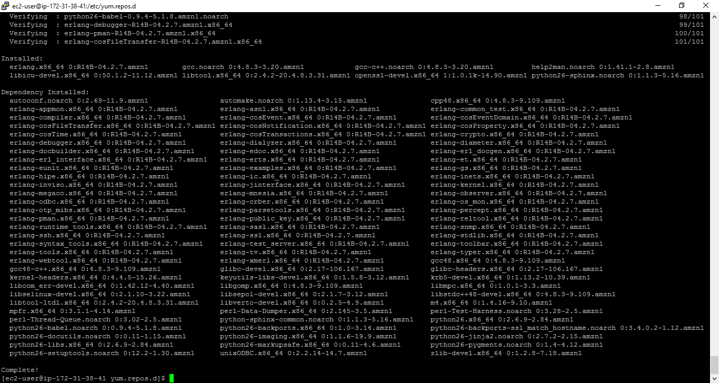

#### SpiderMonkey JS Engine

Download with wget <http://ftp.mozilla.org/pub/mozilla.org/js/js185-1.0.0.tar.gz>

Try sudo wget <http://ftp.mozilla.org/pub/mozilla.org/js/js185-1.0.0.tar.gz>

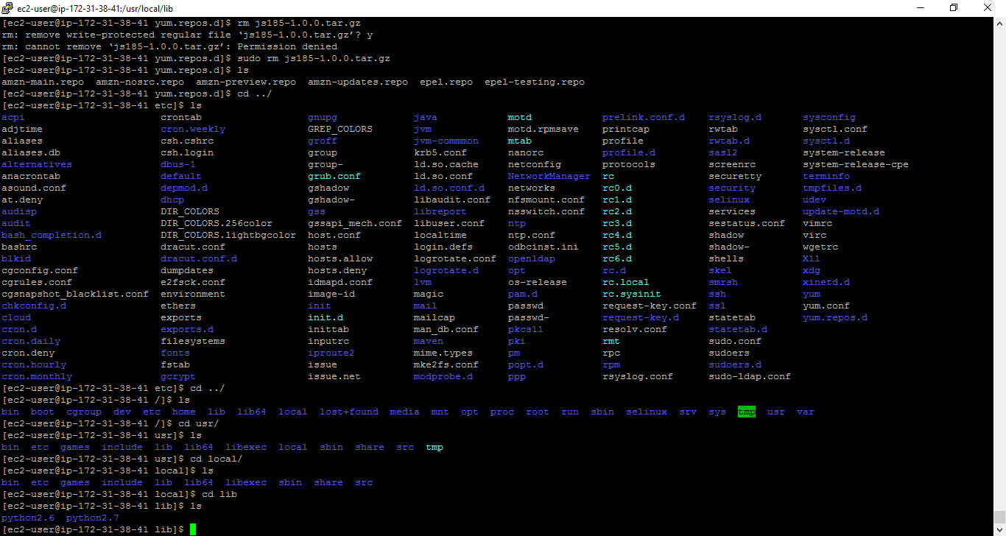

TRY: go to 🡪 /usr/local/lib and then do wget

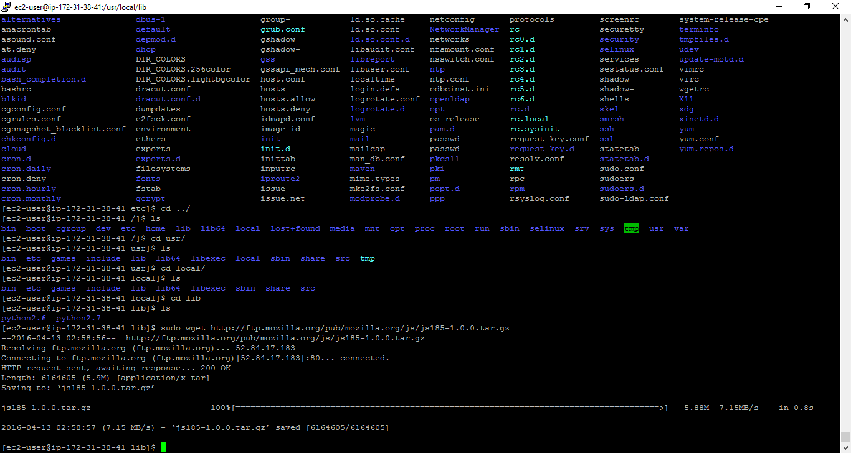

Sudo tar xvfz js185-1.0.0.tar.gz

cd js-1.8.5/js/src

sudo ./configure

sudo make

sudo make install

$sudo yum install autoconf

$sudo yum install autoconf-archive

$sudo yum install automake

$sudo yum install curl-devel

$sudo yum install erlang-asn1

$sudo yum install erlang-erts

$sudo yum install erlang-eunit

$sudo yum install erlang-os_mon

$sudo yum install erlang-xmerl

$sudo yum install help2man

$sudo yum install js-devel

$sudo yum install libicu-devel

$sudo yum install libtool

$sudo yum install perl-Test-Harness

There is no **.tar** file available for CouchDB, so you have to install it from the source. Download the source file of CouchDB, to download [click here](http://www.apache.org/dist/couchdb/source/1.6.1/apache-couchdb-1.6.1.tar.gz).

Create a new directory, and name it CouchDB for example, go into the directory and download CouchDB source by executing the following commands −

$ mkdir CouchDB

$ cd CouchDB/

$ wget

http://www.google.com/url?q=http%3A%2F%2Fwww.apache.org%2Fdist%2Fcouchdb%2Fsource%2F1.6.1%2Fapache-couchdb-1.6.1.tar.gz

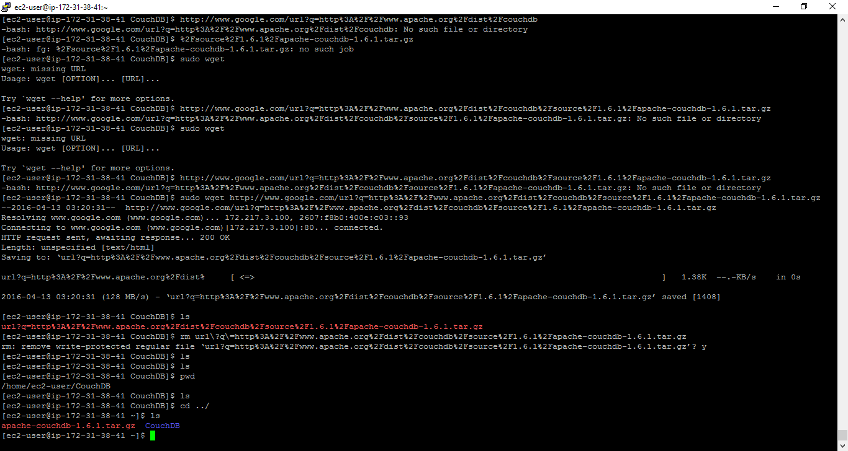

$ tar zxvf apache-couchdb-1.6.1.tar.gz

### **Configuring CouchDB**

Configure CouchDB as follows −

* Browse to the home folder of CouchDB.
* Login as superuser.
* Configure using ./configure prompt as shown below −

$ cd apache-couchdb-1.6.1

$ su

Password:

# ./configure --with-erlang=/usr/lib64/erlang/usr/include/

make && sudo make install

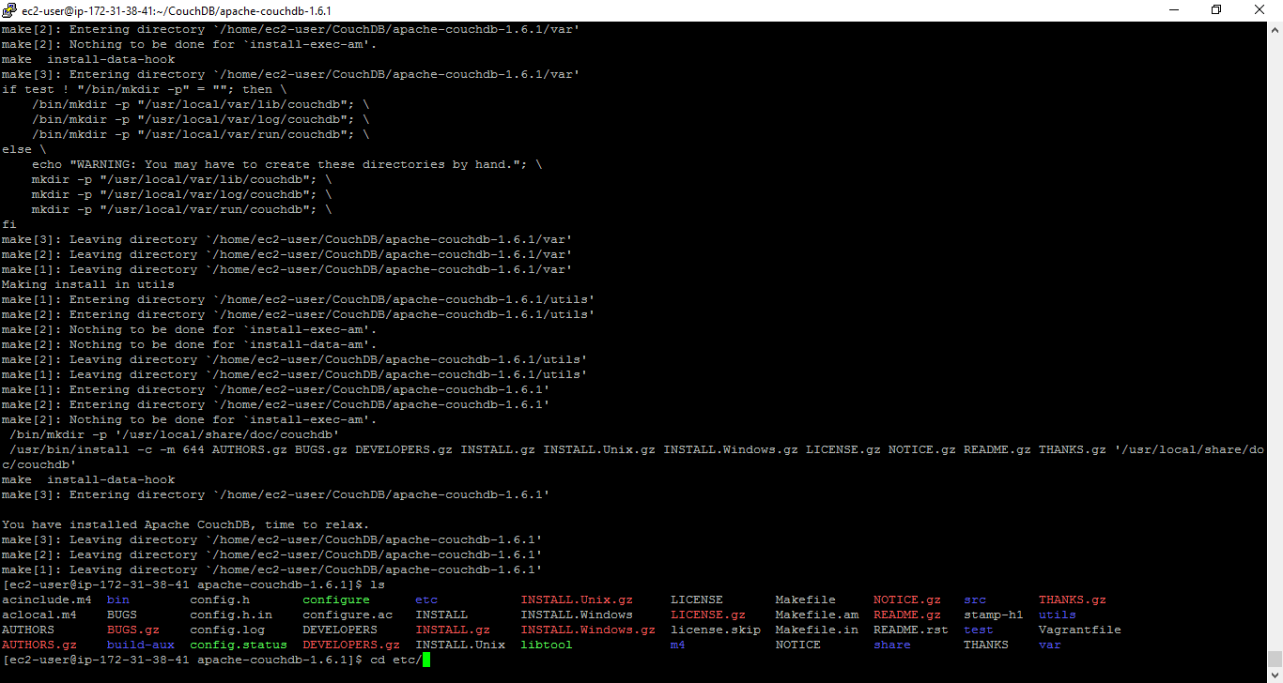

1. Make a couchdb user.
2. sudo useradd -r -d /usr/local/var/lib/couchdb -M -s /bin/bash couchdb
3. Set the file ownerships.
4. sudo chown -R couchdb:couchdb /usr/local/etc/couchdb
5. sudo chown -R couchdb:couchdb /usr/local/var/lib/couchdb
6. sudo chown -R couchdb:couchdb /usr/local/var/log/couchdb
7. sudo chown -R couchdb:couchdb /usr/local/var/run/couchdb
8. sudo chmod 0775 /usr/local/etc/couchdb
9. sudo chmod 0775 /usr/local/var/lib/couchdb
10. sudo chmod 0775 /usr/local/var/log/couchdb

sudo chmod 0775 /usr/local/var/run/couchdb

set password for couchdb

sudo passwd *username*

switch user to couchdb and then start couchdb

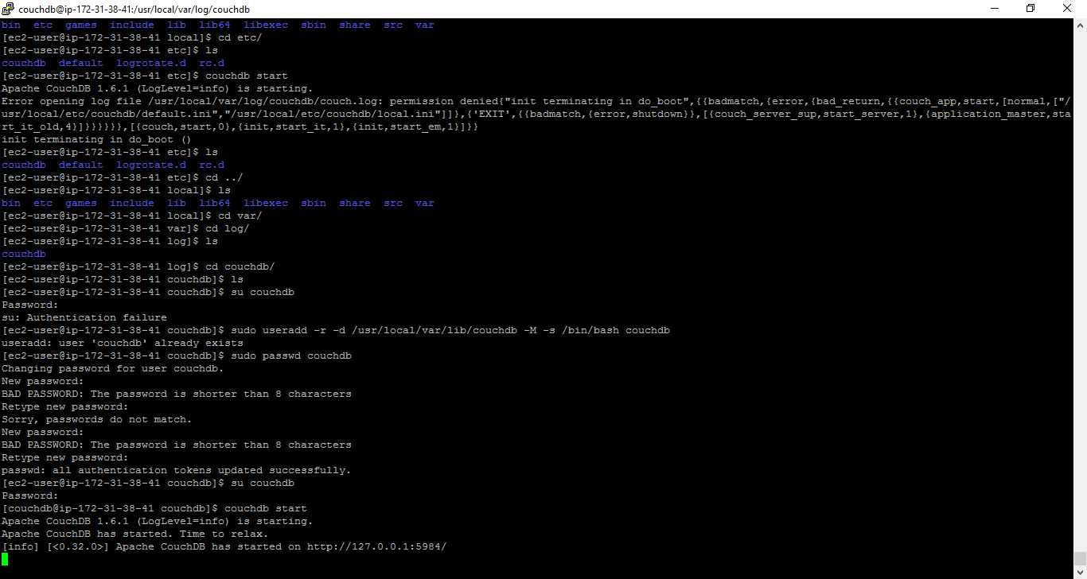

su couchdb couchdb start

curl <http://127.0.0.1:5984/>

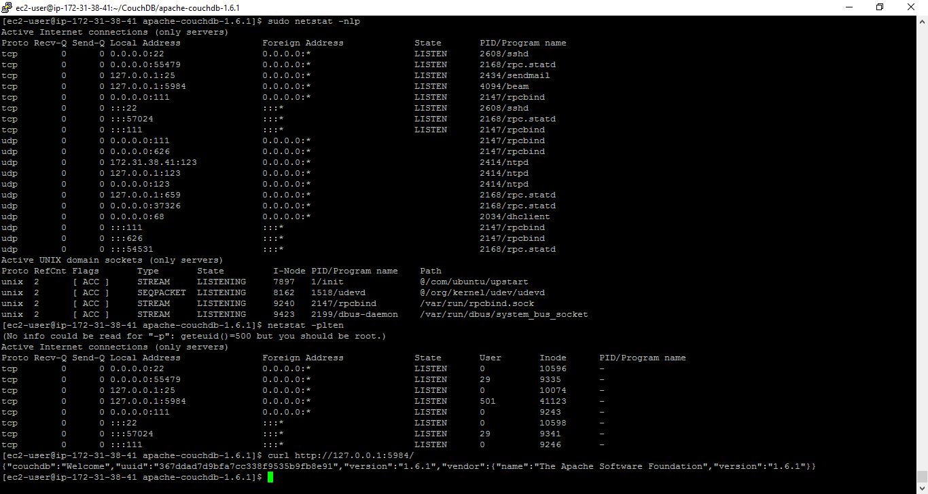

**Change bind address of couchDB so that it is accessible externally:**

By default couchdb only binds to 127.0.0.1 so it’s not accepting requests from other IP addresses. The bind address setting can be modified in the configuration file. For 0.9.0, by default, the default configuration file is located at /usr/local/etc/couchdb/default.ini, and the local configuration file is located at /usr/local/etc/couchdb/local.ini. Settings in the local configuration file will override those in the default one.

Bind address is in the [httpd] section

[httpd]

port = 5984

bind_address = 127.0.0.1

Note that in the local configuration file, this may be commented out with a leading “;”, if you want to set it in the local configuration file, you need to uncomment the bind_address line and modify 127.0.0.1 to some other IP address.

If you modify the bind address to 0.0.0.0, it will bind all interfaces.

**INITIALLY:**

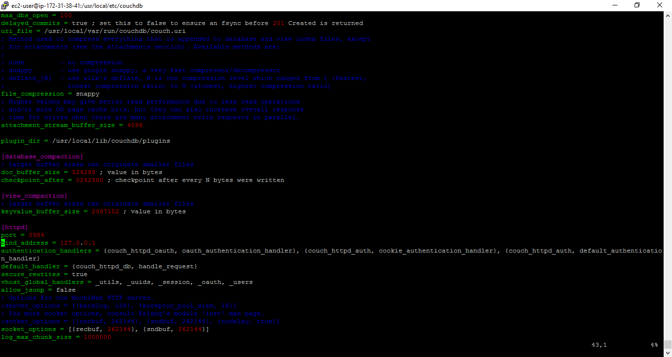

**START/STOP couchDB**

**Sudo service couchdb start**

**Sudo service couchdb stop**